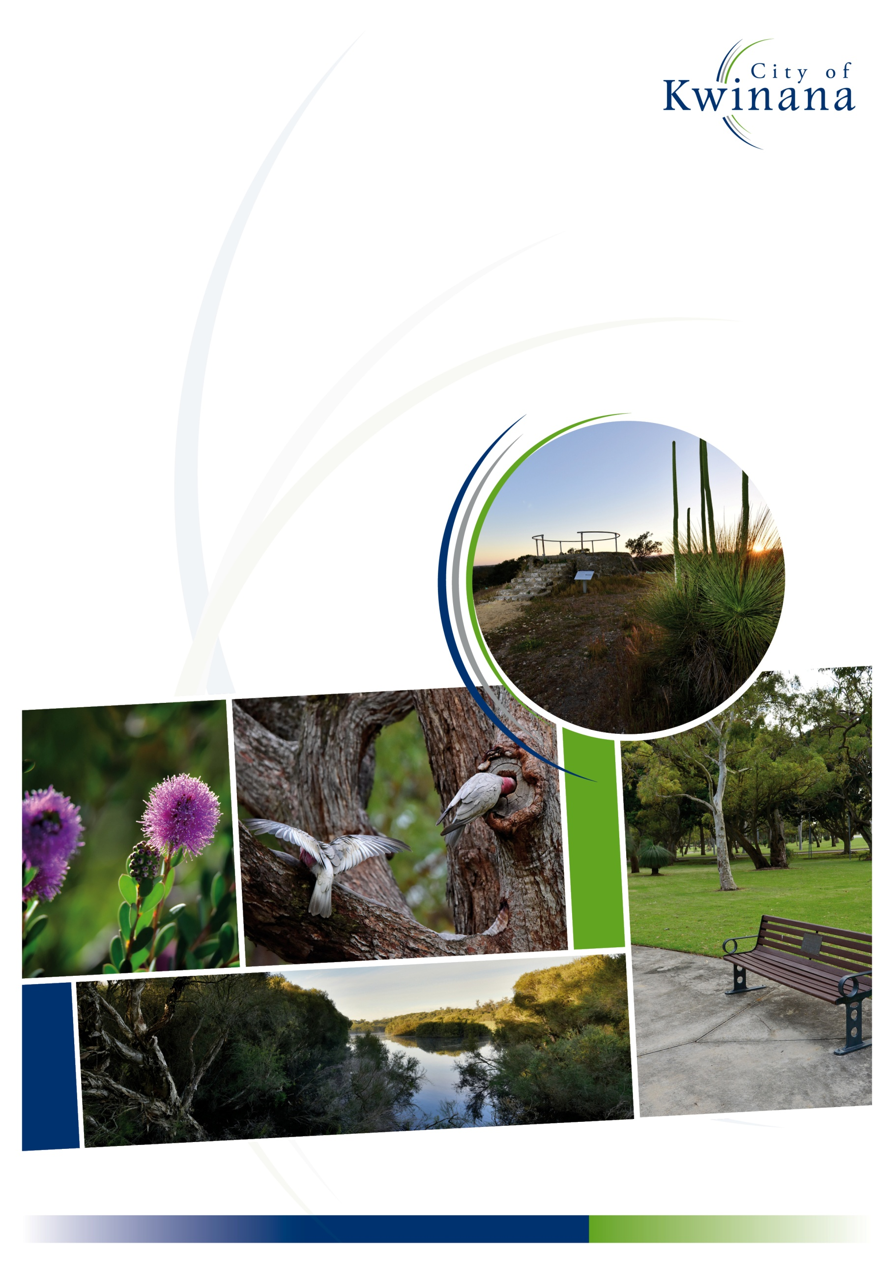

City of Kwinana
Cat Local Law 2022
Note: This is a compilation of the City of Kwinana’s Cat Local Law 2022, which was published in the Government Gazette on 29 March 2022 (pages 2434-2437), as amended and published in the Government Gazette on 11 October 2022 (pages 4910-4911).

City of Kwinana

CAT LOCAL LAW 2022

Contents

PART 1 — PRELIMINARY
1.1 Citation
1.2 Definitions
1.3 Commencement
1.4 Application
PART 2 — KEEPING OF CATS
2.1 Limit on number of cats
2.2 Application for permit
2.3 Decision on application
2.4 Conditions
2.5 Duration of a permit
2.6 Permit not transferable
2.7 Permit to be kept at premises and available for view
PART 3 — CONTROL OF CATS
3.1 Cats in Prohibited Areas
3.2 Cat creating a nuisance
PART 4 — FEES, CHARGES AND COSTS
4.1 Fees, charges and costs
PART 5 — ENFORCEMENT
5.1 Penalties
5.2 Prescribed offences
5.3 Form of notices
5.4 Serving of infringement notices
Schedule 1
Schedule 2

Cat Act 2011
Local Government Act 1995

City of Kwinana

CAT LOCAL LAW 2022

Under the powers conferred by the Cat Act 2011, the Local Government Act 1995 and all other powers enabling it, the Council of the City of Kwinana resolved on 23 February 2022 to adopt the following local law.

PART 1 — PRELIMINARY

1.1 Citation
This Local Law may be cited as the City of Kwinana Cat Local Law 2022.

1.2 Definitions
(1) In this local law unless the context requires otherwise —
Act means the Cat Act 2011;
applicant means the occupier of the premises who makes an application for a permit under this local law;
authorised person has the same meaning as in the Act;
cat has the same meaning as in the Act;
cat management facility has the same meaning as in the Act;
Cat Haven means the Cat Welfare Society Inc., trading as “Cat Haven”;
cattery means a facility where two (2) or more cats are kept, bred, boarded, housed or trained temporarily, whether for profit or otherwise, and where the occupier of the premises is not the ordinary person liable for the control of such cats;
cat prohibited area means an area described in Schedule 2;
CEO means the Chief Executive Officer of the local government;
Council means the Council of the local government;
district means the district of the local government;

local government means the City of Kwinana;
owner in relation to a cat has the same meaning as in the Act;
permit means a permit issued by the local government under this local law;
permit holder means a person who holds a valid permit issued by the local government under this local law;
person liable for the control of means each of the following in relation to a cat —
(a) the registered owner of the cat; or
(b) the owner of the cat; or
(c) the occupier of any premises where the cat is ordinarily kept or ordinarily permitted to live; or
(d) a person who has the cat in their possession or under their control, but does not include a registered veterinary surgeon, or a person acting on their behalf, in the course of their professional practice;
premises has the same meaning as in the Act;
prescribed means prescribed under regulations made under the Act;
RSPCA means the Royal Society for the Prevention of Cruelty to Animals (Inc) of Western Australia;
Schedule means a schedule to this local law;
veterinary clinic has the meaning given to it in the Veterinary Surgeons Act 1960; and
veterinary hospital has the meaning given to it in the Veterinary Surgeons Act 1960.

1.3 Commencement
This local law comes into operation 14 days after the date of its publication in the Government Gazette.

1.4 Application
This local law applies throughout the district.

PART 2 — KEEPING OF CATS

2.1 Limit on number of cats
(1) Subject to subclause (2), a person shall not:
(a) keep more than two (2) cats on the premises at any one time; or
(b) operate a cattery or cat management facility
without a valid permit issued by the local government.
(2) Subclause (1) does not apply to the following:
(a) a cattery or cat management facility operated by either:
(i) the local government; or
(ii) a person or body prescribed by the Cat Regulations 2012;
(b) a refuge of the RSPCA or Cat Haven; or
(c) a veterinary clinic or veterinary hospital.
(3) For the purpose of calculating the number of cats on the premises pursuant to subclause (1), cats under 6 months of age are not to be included.

2.2 Application for permit
(1) Applications to the local government for a permit to be issued pursuant to clause 2.1(1) are to be —
(a) made in writing in a form approved by the local government;
(b) made by the occupier of the premises for which the permit is sought;
(c) where the applicant is not the owner of the premises, an application must include the written consent of all property owners; and
(d) be accompanied by such fee as may be determined by the local government.
(2) In determining an application for a permit pursuant to subclause (1) the local government may consider such matters as it deems appropriate and may request the applicant —
(a) consult with nearby landowners and/or occupiers;
(b) advise nearby landowners and/or occupiers that they may make submissions to the local government on the application for a permit within 14 days of receiving that advice, before determining the application for the permit; or
(c) provide such further or other information as deemed necessary in order for it to make a determination.

2.3 Decision on application
(1) Upon receiving an application for a permit pursuant to clause 2.2(1), the local government may —
(a) approve the application for a permit subject to the conditions specified at clause 2.4(1); or
(b) refuse the application for a permit.
(2) If the local government approves an application under subclause (1), it shall issue a permit to the applicant in the form determined by the CEO.
(3) If the local government refuses to approve an application under subclause (1), it shall advise the applicant accordingly in writing as to the reasons why it was not granted.

2.4 Conditions
(1) Every permit issued by the local government pursuant to clause 2.3(2) are subject to the following conditions —
(a) each cat kept on the premises to which the permit relates shall comply with the requirements of the Act;

(b) the permit holder will provide adequate space for the exercise of the cats;
(c) the premises shall be maintained in good order and in a clean and sanitary condition;
(d) persons undertaking the breeding of cats are to keep records of purchases/transfer of kittens for two years (including details of the buyer’s name, address and the microchip number);
(e) premises may be inspected by the local government; and
(f) such further conditions as the local government considers appropriate, including but not limited to the maximum number of cats permitted to be kept at the premises.
(2) The holder of a permit issued by the local government pursuant to clause 2.3(2) shall comply with all conditions specified by the local government in relation to such permit.
(3) The local government may revoke a permit in the event the permit holder fails to comply with a condition stipulated in a permit issued.

2.5 Duration of a permit
Unless otherwise specified in a condition on a permit, a permit commences on the date of issue and expires —
(a) upon revoking by the local government; or
(b) upon the permit holder ceasing to reside at the premises to which the permit relates.

2.6 Permit not transferable
A permit is not transferrable either in relation to the permit holder or the premises.

2.7 Permit to be kept at premises and available for view
A permit issued by the local government shall be kept at the premises to which it applies and shall be provided to an authorised person on demand.

PART 3 — CONTROL OF CATS

3.1 Cats in Prohibited Areas
A cat shall not be in any cat prohibited area unless the owner of the cat has first obtained written authorisation from the local government.

3.2 Cat creating a nuisance
(1) The person liable for the control of a cat shall prevent the cat from creating a nuisance.
(2) For the purpose of subclause (1), the term nuisance includes —
(a) an activity or condition which causes an unreasonable interference with the use and enjoyment of a person in their ownership or occupation of land; or
(b) interference which causes material damage to land or other property on the land affected by the interference.
(3) Where, in the opinion of an authorised person, a cat is creating a nuisance, the local government may give written notice to a person liable for the control of such cat requiring that person to abate the nuisance within the timeframe specified in such notice.
(4) When a nuisance has occurred and a notice to abate the nuisance is given, the notice remains in force for the period specified by the local government on the notice or until the local government withdraws the notice.
(5) A person given a notice to abate the nuisance shall comply with the notice within the period specified in the notice.

PART 4 — FEES, CHARGES AND COSTS

4.1 Fees, charges and costs
The following are to be imposed and determined by the local government under sections 6.16 to 6.19 of the Local Government Act 1995 —
(a) the charges to be levied under section 31(1)(a) of the Act relating to the removing and impounding of a cat;
(b) the charges to be levied under section 31(1)(b) of the Act relating to keeping and caring for a cat;
(c) the costs incurred by the operator of a cat management facility under section 31(1)(c) of the Act for the microchipping of a cat prior to release if so required under section 33 of the Act;
(d) the cost incurred by the operator of a cat management facility under section 31(1)(d) of the Act for the sterilisation of a cat if so required under section 33 of the Act; and
(e) the costs of the destruction and the disposal of a cat under section 34 of the Act.

PART 5 — ENFORCEMENT

5.1 Penalties
A person who fails to comply with or who contravenes any provision of this local law commits an offence and is liable to a maximum penalty of not less than $200 and not exceeding $1,000 and, if the offence is a continuing offence, a maximum daily penalty of $500.

5.2 Prescribed offences
(1) An offence against any provision of this local law is a prescribed offence for the purposes of section 62(1) of the Act.
(2) The amount appearing in the final column of Schedule 1, directly opposite a prescribed offence in that Schedule, is the modified penalty for that prescribed offence.
(3) For the purposes of guidance only, before issuing an infringement notice to a person in respect of the commission of a prescribed offence, an authorised person should be satisfied that:
(a) the commission of the prescribed offence is a relatively minor matter; and
(b) only straightforward issues of law and fact are involved in determining whether the prescribed offence was committed, and the facts in issue are readily ascertainable.

5.3 Form of notices
(1) The form of an infringement notice is Form 6 in the Cat Regulations 2012, Schedule 1.
(2) The form of withdrawal of the infringement notice is Form 7 in the Cat Regulations 2012, Schedule 1.

5.4 Serving of infringement notices
An infringement notice served under section 62 of the Act or this local law may be given to a person by way of the following:
(1) (a) personal service;
(b) by registered mail addressed to the person; or
(c) by leaving it for the person at her or his last known postal address.
(2) If a person refuses to accept an infringement notice given by way of (a) personal service, the person serving the notice may leave it next to or near the person and orally draw his or her attention to it.

Schedule 1
Prescribed Offences

Item No | Offence | Nature of offence | Modified penalty  $
1 | 2.1(1) | Exceeding maximum number of cats at the premises | 200
2 | 2.4(2) | Failure to comply with a permit condition | 200
3 | 3.1 | Cat in prohibited area without consent | 200
4 | 3.2(1) | Cat causing a nuisance | 200
5 | 3.2(5) | Failure to comply with a notice | 200

Schedule 2
Cat Prohibited Areas
Areas where cats are prohibited —

Common Name | Physical Boundaries | Description
Belgravia Dampland Reserve | Reserve Number 49702 | All bushland and parkland within the listed reserve.
Bertram Sanctuary Reserve | Reserve Number 49067 | All bushland and parkland within the listed reserve.
Clementi Reserve | Reserve Number 41746 | All bushland and parkland within the listed reserve.
Cordata Wetland | Reserve Number 52722 | All bushland and parkland within the listed reserve.
Henley Reserve | Reserve Number 43072 and 50531 | All bushland and parkland within the listed reserves.
“Living Edge” Reserve | Reserve Number 53383  Reserve Number 53384 | All bushland and parkland within the listed reserves.
“Lizard Park” Reserve | Reserve Number 51852 | All bushland and parkland within the listed reserve.
Miller Reserve | Reserve Number 25684 | All bushland and parkland within the listed reserve.
“Sunrise” Reserve | Reserve Number 52361  Reserve Number 52840 | All bushland and parkland within the listed reserves.
Wildflower Reserve | Reserve Number 38747 and Lot 9215 on DP55472 | All bushland and parkland within the listed reserve and lot.

Dated this day of 2022

The Common Seal of the )
City of Kwinana was hereunto )
affixed in the presence of: )

Carol Adams Wayne Jack
Mayor Chief Executive Officer

